

**Module Code & Module Title**

**CS6P05NI Final Year Project**

**Assessment Weightage & Type**

**5% FYP Proposal**

**Semester**

**2021 autumn**

**PROJECT TITLE: The Happy Reader**

**Student Name: Sushant Timilsina**

**London Met ID: 20049076**

**College ID: np01cp4s210251**

**Internal Supervisor: Shubhankar Sharma**

**External Supervisor: Lekhnath Katuwal**

**Assignment Due Date: 28th Nov**

**Assignment Submission Date: 28th Nov**

**Word Count (Where Required):2281**

*I confirm that I understand my coursework needs to be submitted online via Google Classroom under the relevant module page before the deadline in order for my assignment to be accepted and marked. I am fully aware that late submissions will be treated as non-submission and a mark of zero will be awarded.*

Table of Contents

1. Introduction 1

2. Aims and Objectives 4

3. Expected outcomes and deliverables 5

4. Methodology 6

5. Resource Requirement 9

6. Work Breakdown Structure 14

7. Milestone Listing 15

8. Project Gantt chart 17

References 18

Bibliography 19

**Table of Figures**

Figure 1: Showing amazon Ecommerce Sales by product 2

Figure 2: Incremental Model 6

Figure 3: Microsoft Word logo 9

Figure 4 : VS Code Workplace 10

Figure 5 : Ms Excel 11

Figure 6 : Google Chrome 12

Figure 7 : Git 13

Figure 8 : WBS of The Happy Reader application development 14

Figure 9 Gantt chart of Project Development 17

**Table Of tables**

Table 1 : Table showing milestone listing 16

# Introduction

The Happy Reader is a project for an ecommerce store which provides the user option to browse and buy their favorite book online. In this web application, the user can browse their favorite book from the store and buy it through online means.

It's crucial to read reviews of similar apps to get a better understanding of the app's functionality and how it runs and functions. Some website providing this type of services are https://www.barnesandnoble.com, https://www.powells.com etc.

In recent years, e-commerce has become an important part of the global retail landscape. The retail sector, like many other businesses has changed dramatically since the internet's introduction and because of ongoing digitalization of modern life, consumers from practically every country now benefit from the conveniences of online purchases. The number of digital buyers is growing every year as internet access and adoption has grown at a rapid pace around the world. In 2020, nearly two billion people have purchased products or services online, with global e-commerce sales exceeding 4.2 trillion dollars. Global retail e-commerce sales increased by more than 25% in the year of the pandemic, with Argentina reporting the highest percentage increase. Amazon is the most visited online retail website in the world. However, Amazon comes in third place in terms of gross merchandise value (GMV) behind Chinese rivals Taobao and Tmall. The Alibaba Group, Asia's top online commerce supplier, runs both platforms. (Statista, 2022)

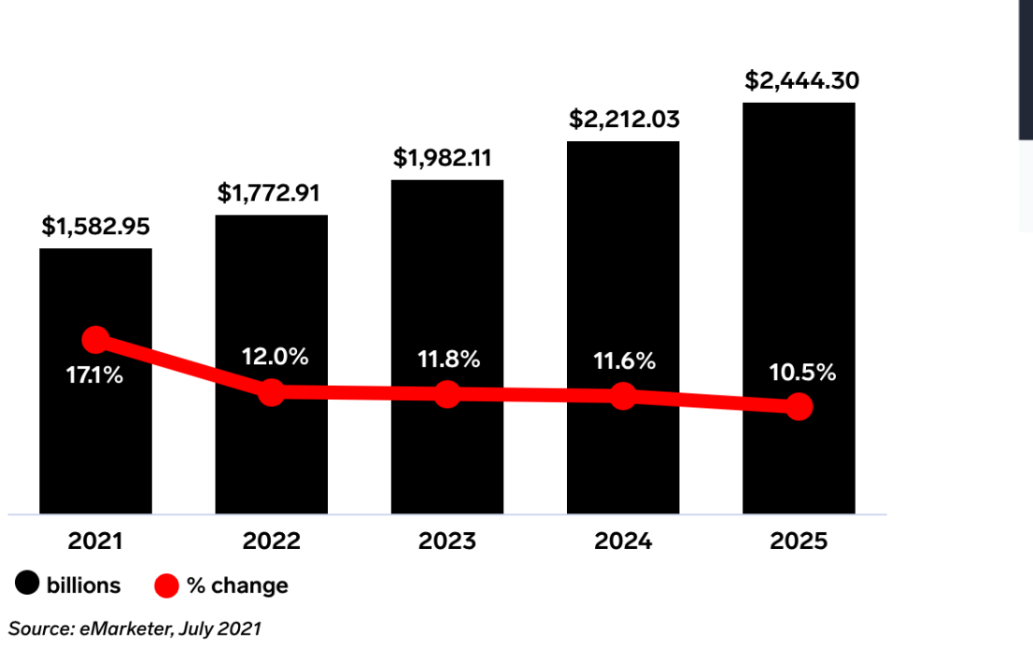

Figure 1: Showing amazon Ecommerce Sales by product

(eMarketer, 2022)

E-Commerce in Nepal is growing in popularity, just as it is around the world, according to a recent report. According to the report of 2019, there are 31 private ISPs in Nepal, serving about 16.67 million people. About 40 percent of these accounts are commercial, according to export.gov There is a large concentration of online E-Commerce activities in Kathmandu Valley and some other important towns in Nepal but as the number of internet users grows in rural regions, so does the number of mobile users and the number of online activities as well. Online shopping in Nepal is now available through numerous websites. The famous ecommerce sites in Nepal are Daraz, HamroBazar, NepBay etc. (Gautam, 2022)

It is where my project fits in. In my ecommerce site the user can buy their favorite book via online and will get the book delivered into their address. Only registered user can order the book by the help of bookworm. The application will have different category differentiated for every genre of books so that the customer can browse the available books according to their favorite category. User can either do online payment through the means of Khalti or can-do cash on delivery while buying the product. User can see the history of their buying.

# **Aims and Objectives**

Aims

* To help local business by upgrading from only offline to online business.
* To help people to buy their required items by sitting at their home.
* To help establish good connection between company and its customers.
* To help reducing management cost of company.
* To help user to find their product without much effort.
* To help growth of ecommerce in Nepal.
* To help reduce unemployment in the country

Objectives

* Gathering the necessary requirement needed for the project.
* Designing the user Interface of the application.
* Coding the application using different languages.
* Testing all the functionality of the application.
* Visiting nearby local stores and making them aware about importance and benefits of ecommerce.
* User can log in and get various information about products and can purchase a suitable product with price and quality comparison.
* Hiring manpower to help deliver goods to the respective customer.

# **Expected outcomes and deliverables**

• Responsive web design.

• Ability to browse by different categories while buying an item.

• Search Function.

• A well-designed shopping cart.

• Option to pay online.

• A user-friendly menu.

• A contact us page.

• Product description.

• A login/register option.

• Social Media Connect Option

# Methodology

The incremental model is a software development process that divides requirements into numerous separate modules during the software development cycle. Each module in this paradigm goes through the processes of requirements, design, implementation, and testing. Every release of the module after then adds functionality to the preceding iteration. The procedure is repeated until the entire system is completed.

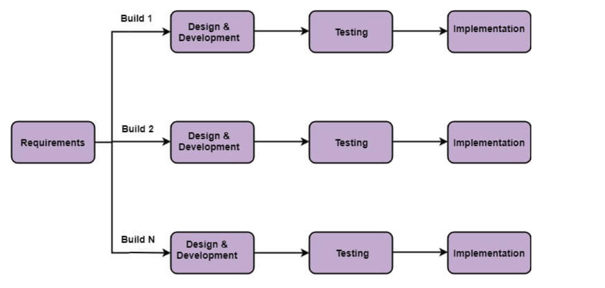

Figure 2: Incremental Model

The various phases of incremental model are as follows:

i. Requirement analysis:

The requirements are identified in the first phase of the incremental model by the product analysis expertise. The requirement analysis team also understands the system's functional requirements. This phase is critical in developing software using the incremental model.

ii. Design & Development:

The design of the system functionality and the development technique are completed successfully in this phase of the Incremental model of SDLC. The incremental model involves style and development phase when software develops new functionality.

iii. Testing:

The testing phase in the incremental model examines the performance of each current function as well as new functionality. Various approaches are utilized to test the behavior of each task throughout the testing phase.

iv. Implementation:

The system's coding phase is enabled by the implementation phase. It includes the final coding that was done during the designing and development phases, as well as the testing of the functionality. After this phase is completed, the number of working products is increased and upgraded to the final system product.

Advantage of Incremental Model

• Errors are easily identifiable.

• It's a lot easier to test and debug.

• More adaptable.

• Risk is easy to manage because it was handled at the iteration.

• Important functionality is delivered to the client early.

Disadvantage of Incremental Model

• Good planning is required.

• The total cost is quite expensive.

• Module interfaces must be clearly defined. (javatpoint, 2021)

Reasons for using Incremental Model

• My project had a lengthy development schedule.

• The requirement was clear for my project.

• I was not much skilled in start of the project.

# Resource Requirement

* No specific hardware required.

**For Software**

* MS Word

You may use Microsoft Word to generate professional-looking documents, reports, letters, and resumes. Microsoft Word includes more functionality than a plain text editor, such as spell check, grammar check, text and font formatting, HTML support, image support, complex page layout, and more.

In my project MS word is used for documentation.



Figure 3: Microsoft Word logo

(Hope, 2021)

* Visual Studio Code.

Microsoft's Visual Studio Code (often known as VS Code) is a free open-source text editor. VS Code includes multiple important features that have made it one of the most popular development environment tools in recent years. VS Code is compatible with a wide range of programming languages, including Java, C++, Python, CSS, Go, and Dockerfile.

In my project VS code is used as text editor for developing my application.

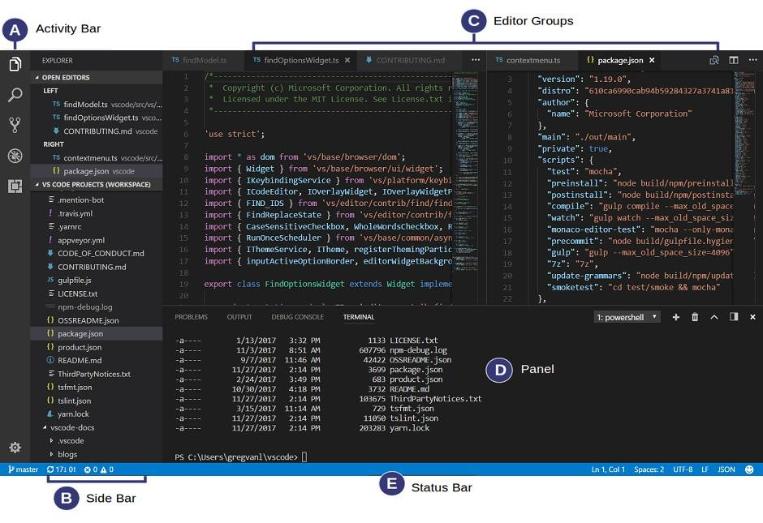

Figure 4 : VS Code Workplace

(Mustafeez, 2022)

* MS Excel

Microsoft Excel is a spreadsheet tool developed by Microsoft that allows users to organize, format, and calculate data using formulae. It includes, among other things, the ability to make simple calculations, use graphing tools, construct pivot tables, and create macros. To organize and manage data, spreadsheet applications like MS Excel use a collection of cells organized into rows and columns. They can also use charts, histograms, and line graphs to display data.

It is used in my project for making different charts and graphs. (Techopedia, 2020)



Figure 5 : Ms Excel

* Web browser like chrome, opera etc.

Google Chrome is a free Internet browser that was released on December 11, 2008.

Synchronization with Google services and accounts, tabbed browsing, and automatic translation and spell checking of web pages are among its capabilities. It also has an integrated address bar/search bar known as the omnibox.

It is used in my project for running the web application, searching different necessary materials etc.



Figure 6 : Google Chrome

(Hope, 2022)

* Git

Linus Torvalds, the developer of Linux, developed Git, a content management and tracking system. It comprises a directory that is updated regularly when new codes are introduced during application or website development. Git also keeps track of changes made to data that has been saved. It is also straightforward, adaptable, and easy to share among project or team members. (Techopedia, 2022)

Git is used for version control of my application.



Figure 7 : Git

# Work Breakdown Structure

To enable efficient project management, extensive planning is required to describe the project objectives in sufficient depth. The WBS lays the groundwork for defining work about project goals, as well as establishing a system for tracking job completion. WBS defines the project's scope of work in terms of deliverables, then breaks them down further into components. The WBS can also specify the project's lifecycle process as well as deliverables relevant to the project, program, or other higher-order entity, depending on the decomposition approach employed. This project scope decomposition strikes a good compromise between management's demand for control and a sufficient level of detail. WBS also serves as a framework for project status and progress reports for the project management team. (Sheng, 2019)

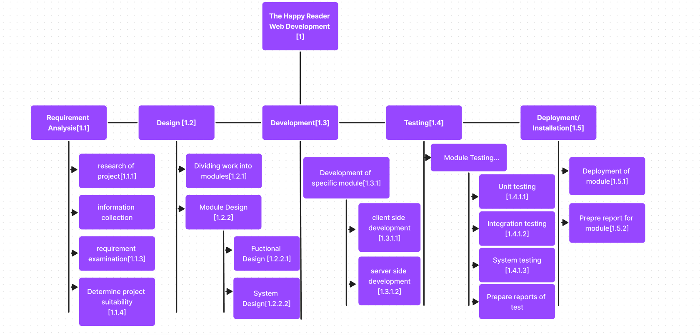

Figure 8 : WBS of The Happy Reader application development

# Milestone Listing

A project milestone is a management tool for defining a certain point in a project's timeline. These markers can be used to indicate the beginning and end of a project, as well as the completion of a key phase of work. Milestones can represent anything that has begun or completed, although they are most used as a scheduling tool. Milestones are vital for precise project planning and scheduling because they allow you to more properly predict the time it will take to finish your project by identifying important dates and events. They're a vital part of project documents like the project schedule, project charter, and project plan because of their variety. (Westland, 2021)

Here are some milestones that can be achieved while developing this project.

|  |  |  |  |
| --- | --- | --- | --- |
| S. N | Milestones | Description | Days |
| 1 | Project planning | Project is planned accurately, and decision is taken on how the project will be handled. | 5 |
| 2 | Proposal writing | Proposal is submitted about the application which is going to be developed. | 6 |
| 3 | Requirement  Gathering | Requirement is gathered by means of similar apps, survey, and interview. | 22 |
| 3 | Design | Prototype and designs are designed in this phase | 60 |
| 4 | Development | System design prototype in the Design Phase is converted into a working information system that addresses all documented system requirements. At the end of this phase, the working system will enter the Test Phase. | 98 |
| 5 | Testing | Checking the performance of each existing function as well as additional functionality and errors, bugs, and interoperability. | 20 |
| 6 | Deployment | The final stage of initial development, where the software is put into production and runs actual business. | 14 |
| 7 | Documentation | Documentation of detailed information of the new system function along with how it works in the system interface. | 201 |

Table 1 : Table showing milestone listing

# Project Gantt chart

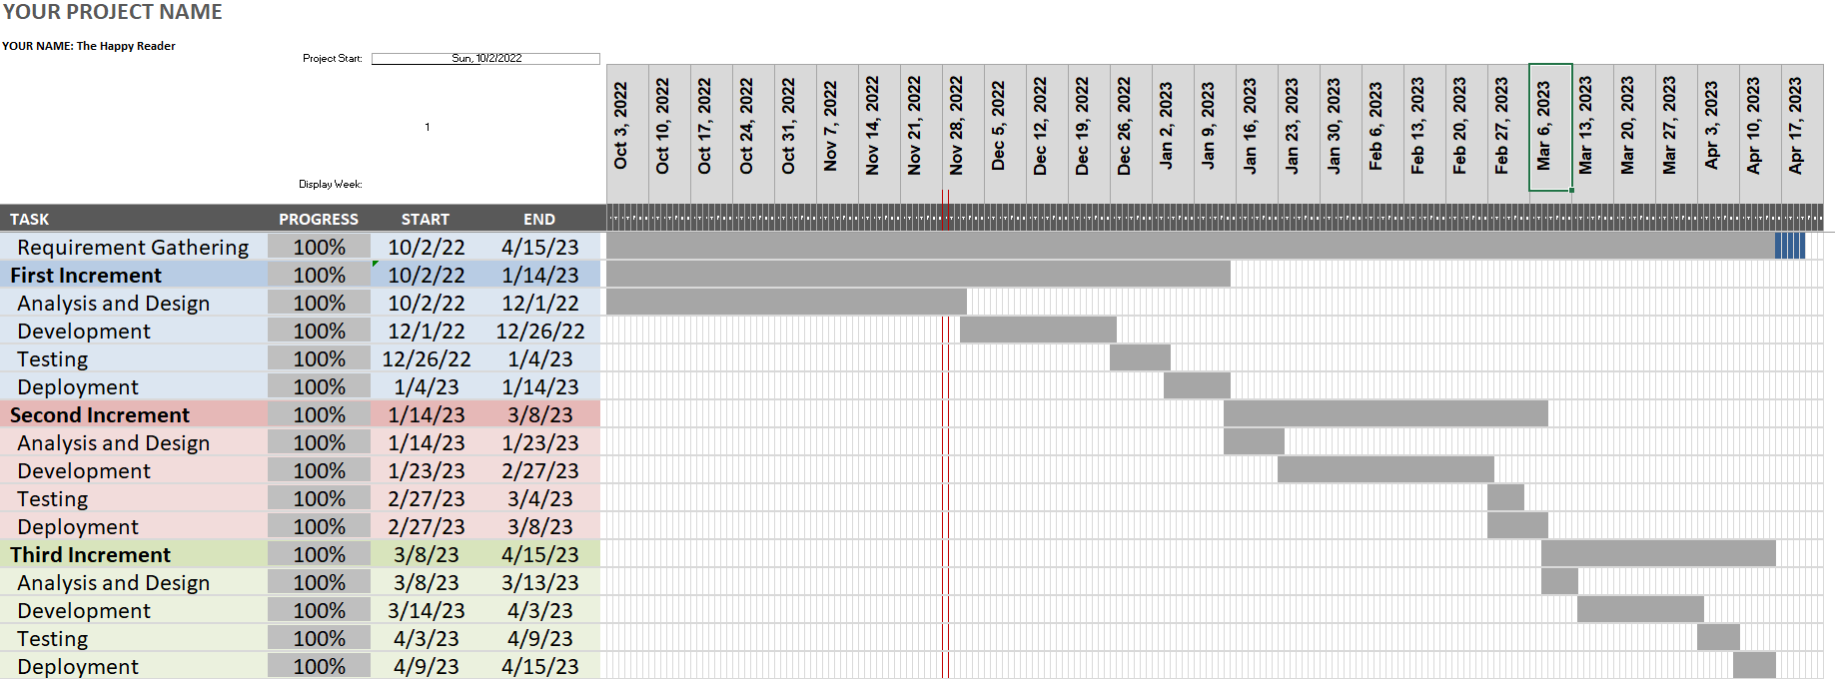

Figure 9 Gantt chart of Project Development

# References

eMarketer, 2022. *Ecommerce Statistics: Industry benchmarks & growth.* [Online]   
Available at: https://www.insiderintelligence.com/insights/ecommerce-industry-statistics/  
[Accessed 12 November 2022].

Gautam, Y., 2022. *Status of E-Commerce In Nepal.* [Online]   
Available at: https://www.everestparked.com/post/status-of-e-commerce-in-nepal#  
[Accessed 12 November 2022].

Hope, C., 2021. *Microsoft Word.* [Online]   
Available at: https://www.computerhope.com/jargon/m/microsoft-word.htm

Hope, C., 2022. *Chrome.* [Online]   
Available at: https://www.computerhope.com/jargon/c/chrome.htm

Mustafeez, Z., 2022. *What is Visual Studio Code?.* [Online]   
Available at: https://www.educative.io/answers/what-is-visual-studio-code

Sheng, R., 2019. Systems engineering and integration. *Systems Engineering for Aerospace,* 1 03.pp. 9-32.

Statista, 2022. *E-Commerce worldwide-statistics & facts.* [Online]   
Available at: https://www.statista.com/topics/871/online-shopping/#dossier-chapter1

Techopedia, 2020. *Microsoft Excel.* [Online]   
Available at: https://www.techopedia.com/definition/5430/microsoft-excel

Techopedia, 2022. *Git.* [Online]   
Available at: https://www.techopedia.com/definition/28960/git

Westland, J., 2021. *What Are Milestones in Project Management?.* [Online]   
Available at: https://www.projectmanager.com/blog/milestones-project-management

# Bibliography

eMarketer, 2022. *Ecommerce Statistics: Industry benchmarks & growth.* [Online]   
Available at: https://www.insiderintelligence.com/insights/ecommerce-industry-statistics/  
[Accessed 12 November 2022].

Gautam, Y., 2022. *Status of E-Commerce In Nepal.* [Online]   
Available at: https://www.everestparked.com/post/status-of-e-commerce-in-nepal#  
[Accessed 12 November 2022].

Hope, C., 2021. *Microsoft Word.* [Online]   
Available at: https://www.computerhope.com/jargon/m/microsoft-word.htm

Hope, C., 2022. *Chrome.* [Online]   
Available at: https://www.computerhope.com/jargon/c/chrome.htm

Mustafeez, Z., 2022. *What is Visual Studio Code?.* [Online]   
Available at: https://www.educative.io/answers/what-is-visual-studio-code

Sheng, R., 2019. Systems engineering and integration. *Systems Engineering for Aerospace,* 1 03.pp. 9-32.

Statista, 2022. *E-Commerce worldwide-statistics & facts.* [Online]   
Available at: https://www.statista.com/topics/871/online-shopping/#dossier-chapter1

Techopedia, 2020. *Microsoft Excel.* [Online]   
Available at: https://www.techopedia.com/definition/5430/microsoft-excel

Techopedia, 2022. *Git.* [Online]   
Available at: https://www.techopedia.com/definition/28960/git

Westland, J., 2021. *What Are Milestones in Project Management?.* [Online]   
Available at: https://www.projectmanager.com/blog/milestones-project-management